Design and practical realization of the Snake game using Arduino Nano
DO NOT DELETE THIS LINE (PRESS PARAGRAPH MARKS (¶) TO SEE THIS LINE)

Iva Cvetanović  Dept. of Microelectronics  Faculty of Electronic Engineering  Niš, Serbia  iva.cvetanovic@elfak.rs N/A |  | Petar Nikolić  Dept. of Microelectronics  Faculty of Electronic Engineering  Niš, Serbia  nikolicpetar@elfak.rs N/A
DO NOT DELETE THIS LINE (PRESS PARAGRAPH MARKS (¶) TO SEE THIS LINE)

Abstract— This project is based on the world-famous Snake game, which was first introduced to the public in 1997, with its fairly simple premise: the player controls the movements of the snake, leading it towards the apple – a single pixel on the screen – which, after being eaten, causes the snake’s body to elongate. After pressing a button, the player exits the pre-game state (including a welcome screen and, if second button is pressed, the leaderboard is shown on a 16*2 Liquid Crystal Display, i.e. LCD) and enters the in-game state, with the LCD now showing the player’s current score determined by the number of eaten apples, and both the snake and the apple being shown on two LED (Light Emitting Diode) matrices daisy-chained together. In case of the snake colliding with its own body, the LCD shows the game-over screen, updating the leaderboard according to the data stored in the EEPROM (Electrically Erasable Programmable Read-Only Memory) to show the three highest scores and the names entered by the players who achieved them.
Keywords—snake game, microcontroller, EEPROM, interrupt, LCD.

Introduction
In the 1990s, mobile phones were used almost entirely for communication purposes, in other words – for texting and calling. After the release of Nokia’s [1] 6110 phones in 1997, they found themselves expanding their target audience, as their phones now included a game, which attracted younger users as well and presented a stepping stone towards today’s smartphones. Developed by the company’s Taneli Armanto [2] and inspired by his interest and lifelong passion for board and arcade games, Snake was a rather simple game with some limitations, such as the number of keys used to control the game, a limited display and a small amount of memory available on the devices at the time. Although mobile gaming has come a long way since then, the simplicity and engaging premise have allowed this game to withstand the passage of time and remain a fond memory to some people and an inspiration to others [3].
With all this taken into consideration, the aim of this paper is to recreate a classic Snake game by implementing a circuit with a microcontroller unit i.e. MCU which controls the matrix comprised of LEDs.

Practical realization
The snake game was realised on a breadboard with the components connected to an Arduino Nano [4] board, with SPI (Serial Peripheral Interface) signals being monitored on the oscilloscope, as shown in Fig. 1. The code was written in Arduino IDE [5]. Functionality of the schematic was simulated in Proteus simulator [6].
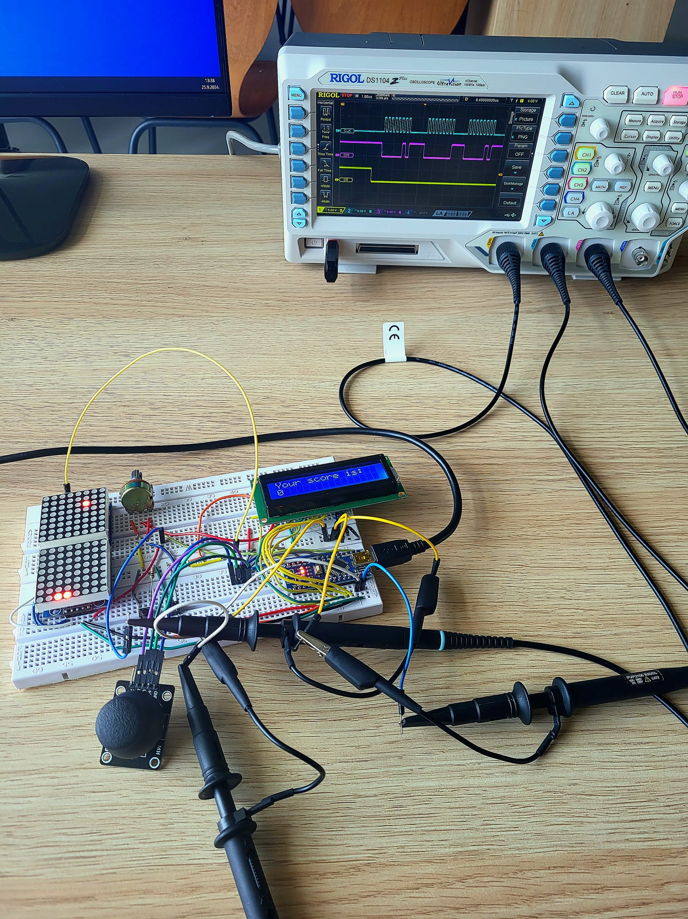
- Game circuit realised on a breadboard in a laboratory.
The circuit is shown in Fig. 2. User interface consists of an LCD, two interrupt buttons in pull-down configurations (connected to D2 and D3 pins of Arduino Nano) and a joystick. Register Select, Enable and Data pins (4-7) of the LCD are connected to pins D4-D9 on the Arduino Nano board, respectfully. Analog pins of the joystick are connected to A0 and A1 pins (joystick is simulated as a pair of potentiometers in Proteus). MAX7219 [7] drivers for LED matrices use SPI communication protocol with their Clock pin connected to D13, Chip Select/Load pin connected to D10 and Data Input pin connected to D11. When more LED matrices are in a daisy-chain, the Data Output pin of the first matrix is connected to Data Input pin of the next matrix. This way, more than one matrix can be used for display purposes.
Virtual serial communication terminal is only included in the simulation (and connected to D0 and D1 pins).
It is important to notice that when this circuit is connected on a real breadboard, one extra resistor (value is typically 220 Ω) is used for limiting the current through Backlight pins of the LCD and also one 10 kΩ potentiometer is needed for the regulation of brightness of the LCD.

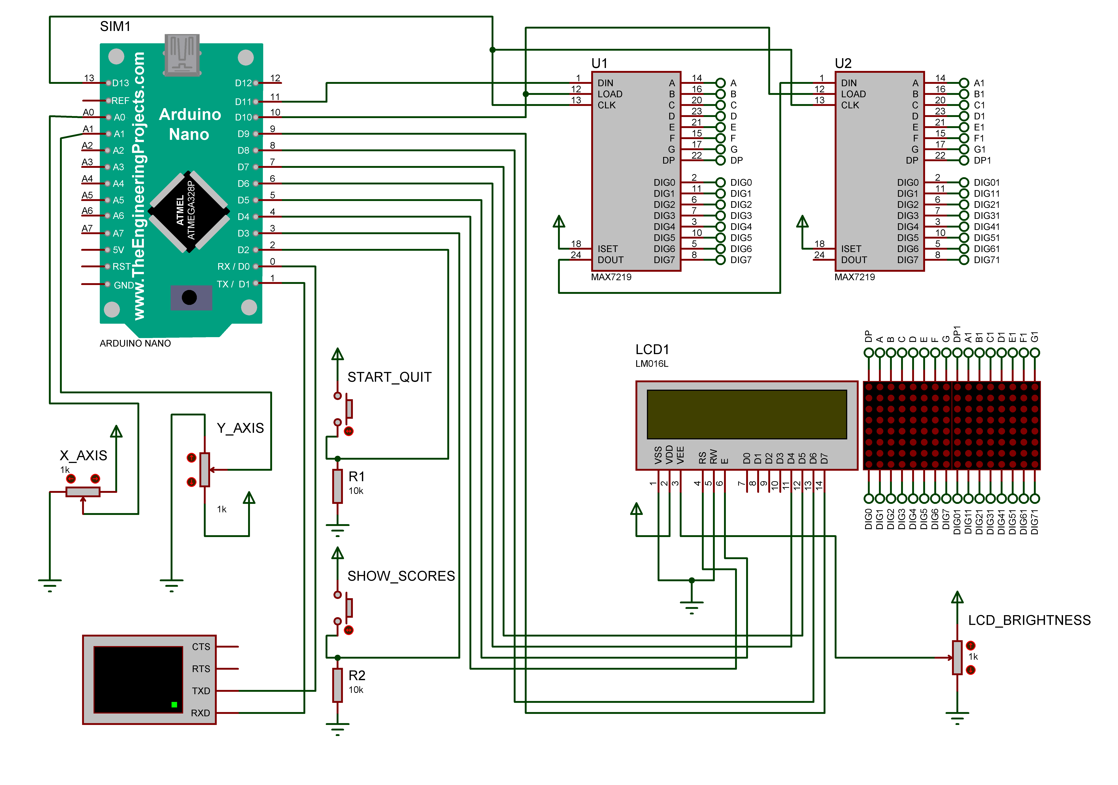

- Proteus schematic for the snake game.

Components used
Following is the list of all the components that were used in the making of the snake game:
- Arduino Nano [4].
- 8*8 LED matrix with MAX7219 [7] driver (code was written for an arbitrary number of matrices, so their number may vary).
- Joystick.
- 16*2 LCD display with Hitachi HD44780 [8] driver.
- EEPROM (internal to ATmega328P [9]).
- 2*buttons (one for start or quit and second for showing the scores using the interrupts).
- 1*potentiometer (for LCD brightness control).
- 2*10 kΩ resistors (for pull-down configuration of the buttons).
- 220 Ω resistor (limiting the current through the backlight of the LCD).
- wires for connections.
- breadboard.

LED Matrix
An 8x8 LED Display consists of 64 LE diodes arranged in rows and columns, forming a grid shown in Fig. 3. Internally, the cathodes of each diode are interconnected within a column, while the same is true for the anodes of each row; the aforementioned configuration is known as Column Common Cathode, which is the case with the model used for this project, and the reversed setup is referred to as Row Common Cathode. Both the row and column of a specific diode have to be polarized in order for it to be lit up: in this particular case, the appropriate row should be connected to the power supply, meanwhile the corresponding column ought to be grounded – this way a current pathway is created and the LED lights [10].
By controlling either an entire row or column at a given time, utilizing a method called scanning, it is possible to control the LED Display, allowing the display of any image without the accidental activation of diodes not needed for the intended result. It occurs in 8 iterations, as many as the number of rows/columns is [10].
In order to establish communication with the LED Display, it is required to include a driver. The MAX7219/MAX7221 are serial input/ output common-cathode display drivers that interface microprocessors to 7-segment displays, bar-graph displays or 64 individual LE diodes and are compatible with SPI. Pictured below is a table showing the register address map [7].
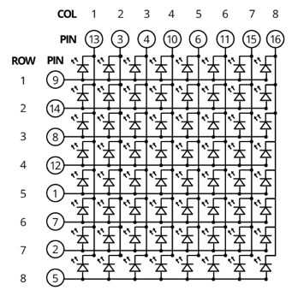
- Arrangement of LEDs in an LED matrix.
Registers of interest in this project are the shutdown register (operating normally), the display test register (set to operate normally as well), the decode mode register (in no decode mode), the scan limit register (which displays digits 0-7), and the intensity register (intensity established at medium) [7]. The addresses of these registers are shown in Fig. 4.
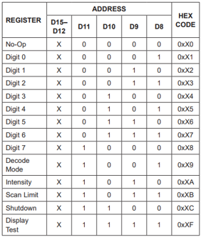
- MAX7219 registers.

SPI Interface
For the MAX7219, 16-bit packets of serial data are shifted into the internal 16-bit shift register at Din with each rising edge of the clock, regardless of the LOAD state. SPI is a synchronous, full duplex main-subnode-based interface and, due to the previously mentioned, the data from the main (the device which generates the clock signal) or the subnode is synchronized on the rising clock edge [7][11].
To initiate SPI communication, the master (main) has to provide the clock signal and select the slave (subnode) by activating the CS signal; for the MAX7219, CS must be low in order for data to be transferred in or out. Due to its full-duplex nature, both the main and the subnode can send data simultaneously, which means that the data is transmitted and received at the same time [11].
Communication protocols are used with the intention of establishing communication between electronic devices, with SPI being one of the most common ones, aside from I2C and UART. The advantages of using SPI include the data being streamed continuously and without interruption, no complicated slave addressing system (unlike I2C), higher data transfer rate than I2C which makes it almost twice as fast, and separate Master Input/Slave Output and Master Output/Slave input lines, making it capable of sending and receiving data at the same time [12].
As previously described, the protocol operates on the principle of using a master device and one or multiple slave devices: in order for the communication to begin, the clock signal synchronizes the output of data bits from the master (in this case, the ATmega328P MCU) to the sampling of bits by the slave (namely, the MAX7219 driver), with one bit of data being transferred during each clock cycle [12].
After outputting the clock signal, the Arduino Nano microcontroller switches the CS (Chip Select) pin to a low voltage state during which communication is enabled – in case of a high voltage level, communication is disabled and the devices enter a non-transmitting state. This is shown in Fig. 5.
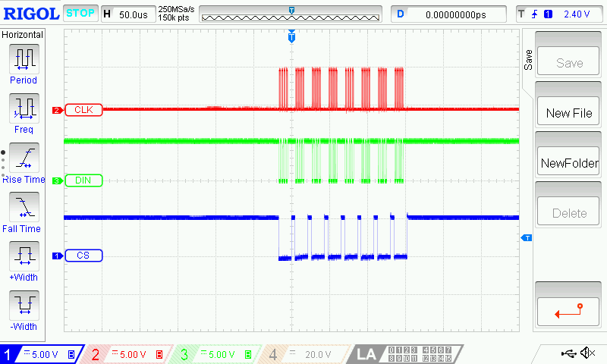
- Role of CLK and CS signals in SPI transmissions.
The data is sent and read one bit at a time, and in this particular case, the first row of the first matrix’s address and data and the first row of the second matrix’s address and data are sent first, in a singular transaction and in that exact order, since the registers of the first rows have the same address, they just belong to different matrices. The event occurs a total of eight times during each cycle of transmission, meaning that all eight rows of both matrices have had their addresses and data sent. These bits are included in the DIN signal shown in Fig. 6.
- DIN signal in SPI transmissions.
In order to light up a single pixel on an LED matrix via SPI, it is crucial to understand that the MAX7219 driver expects data to be sent in two bytes, with the first one specifying the row address, and the second specifying the column data; the former bearing the address of the row, and the latter containing the binary value representing the number of the column intended to turn on (prefaced by 0b, which indicates that the following value is in binary code, as well as a 0 indicating an unlit pixel and a 1 placed in the position of the pixel supposed to be lit up). After setting the CS pin to low and initializing SPI, as well as sending the data – with the two bytes serving as x and y coordinates of the pixel, respectively – the CS pin is set to high in order to store the data that was previously sent. The most convenient way to send the data and control the CS pin is by using a void type function, where the first variable being passed corresponds to the row, and the second indicates the column.
If, however, the aim was lighting up an entire row, considering the data is sent by calling the same function as before, the first byte would indicate the position of the row, while the second would be 0b11111111 (or, rather, 255 in decimal and 0xFF in hexadecimal). Nevertheless, lighting up an entire column is not as simple. It includes manipulating multiple rows at once, ideally using a for loop which passes through every single row, in which the function is called once again by sending the value of the current iteration’s row as the first variable and the same binary number corresponding to the intended column for every iteration. That way the pixels within the same column, but in different rows, are all lit up.

Code and function diagrams
The code written for the snake game consists of two C++ libraries called “GameBase” and “SnakeGame” that are then included in the main code written in Arduino IDE. “GameBase” defines the “Snake” class, the “Dot” structure and other constants regarding the dimensions of the game screen, which may vary depending on the number of matrices that are daisy-chained. The “GameBase” library is included in the “SnakeGame” library which defines all the functions and variables needed for creating the game frame and showing it on the matrices. Also “SnakeGame” includes EEPROM functions for reading and writing best scores achieved by players.
The Snake game can be portrayed as an FSM (Finite State Machine), since there are three different game states (“preGame”, “inGame” and “gameOver”). Transitions between these states are shown in Fig. 7. In the “preGame” state, the player can press the interrupt button for showing the best scores on the LCD, while in the “gameOver” state the current player score can be written to EEPROM along with a three character player name, but only when that score is greater than the last score written in EEPROM.
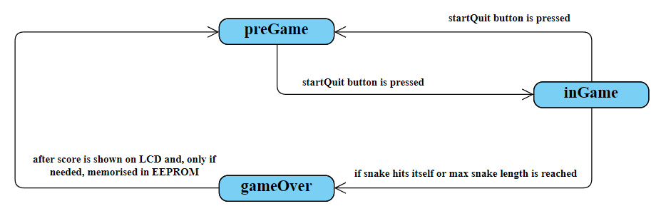
- Snake game as an FSM.
The most important function that is included in „SnakeGame“ is the „updateFrame“ function which is responsible for creating the next frame to be shown on the LED matrix. The diagram for this function is shown in Fig. 8. Based on the snake’s head coordinates in the next frame and the data about the previous frame that was shown, the next frame data is formed. Since this function is running in the „inGame“ state, when the snake’s next frame head coordinates match any part of the snake’s body coordinates, the snake hit itself, so the game transitions to the „gameOver“ state. Transition to the „gameOver“ state also happens when the maximum snake’s body length is reached.
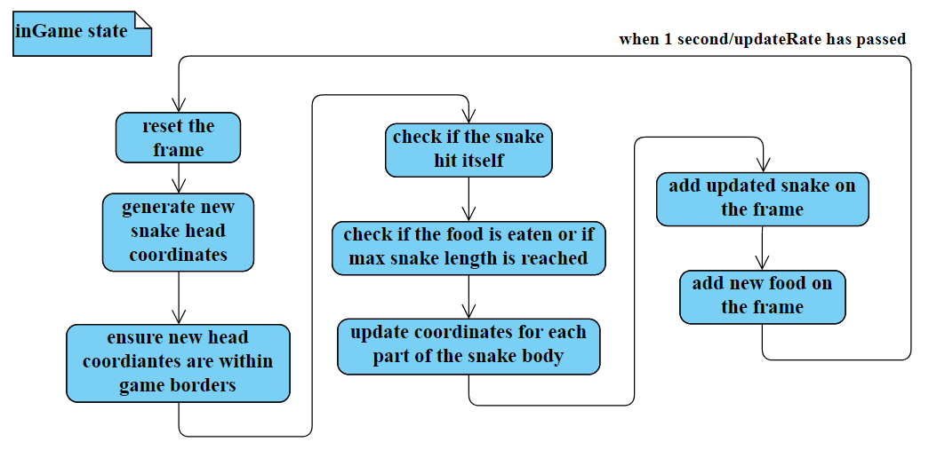
- Diagram for function updateFrame.
As stated before, player scores can be written to EEPROM, when the game is in „gameOver“ state. The diagram for the function responsible for this process is shown in Fig. 9. An important notice is that the external hardware interrupts are disabled when writing to or reading from the EEPROM. This is done so that the content of the memory won’t be corrupted.
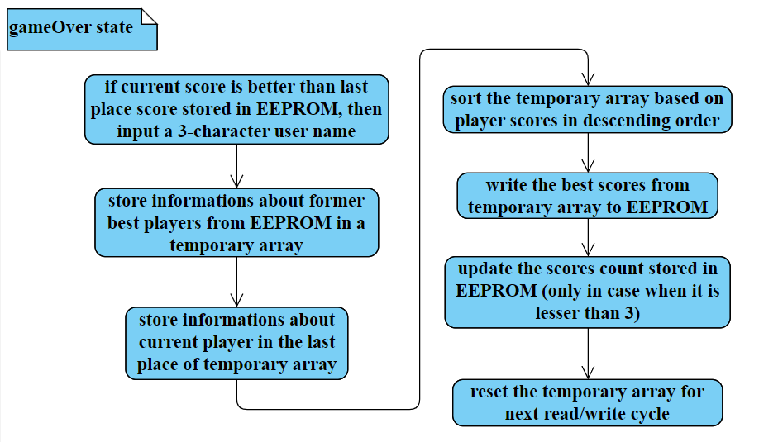
- Diagram for function EEPROMputPlayerInfoInMemory.

Game demonstration
In this chapter, the reader will get a better understanding of the playthrough of the game. Different game stages are shown in the upcoming figures. In this case, only one LED matrix was used.
Starting screen, button function explanation screen and the screen when there are no scores written in EEPROM are shown in Fig. 10. These screens are shown on the LCD, while the LED matrix is inactive.
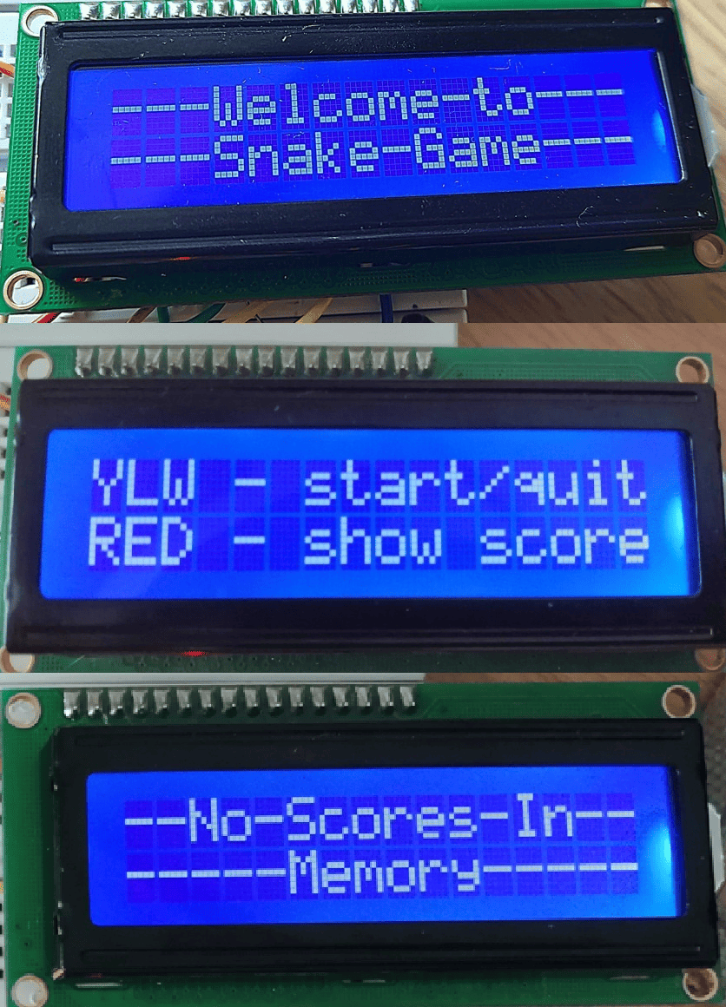
- Starting screen, pre-game screen and „no scores in memory“ screen.
When the game is in motion, the LED matrix is showing the snake and the apple, while the LCD is showing the current score. When the game ends, the LCD is showing the final score, as shown in Fig. 11.
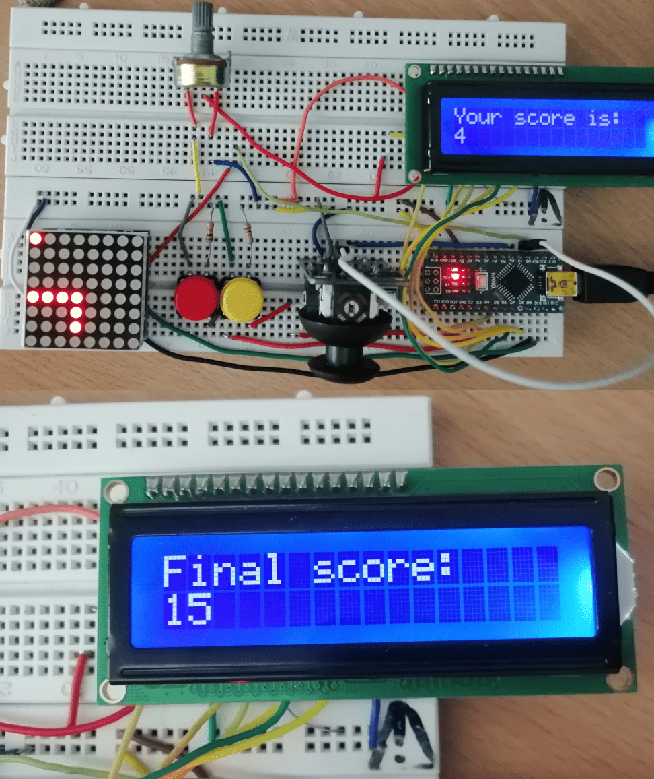
- In-game and game-over state.
After the game is over, the player can input their three-character name via serial communication. After memorising this data, a message is shown on the LCD indicating a successful score save. These screens are shown in Fig. 12.
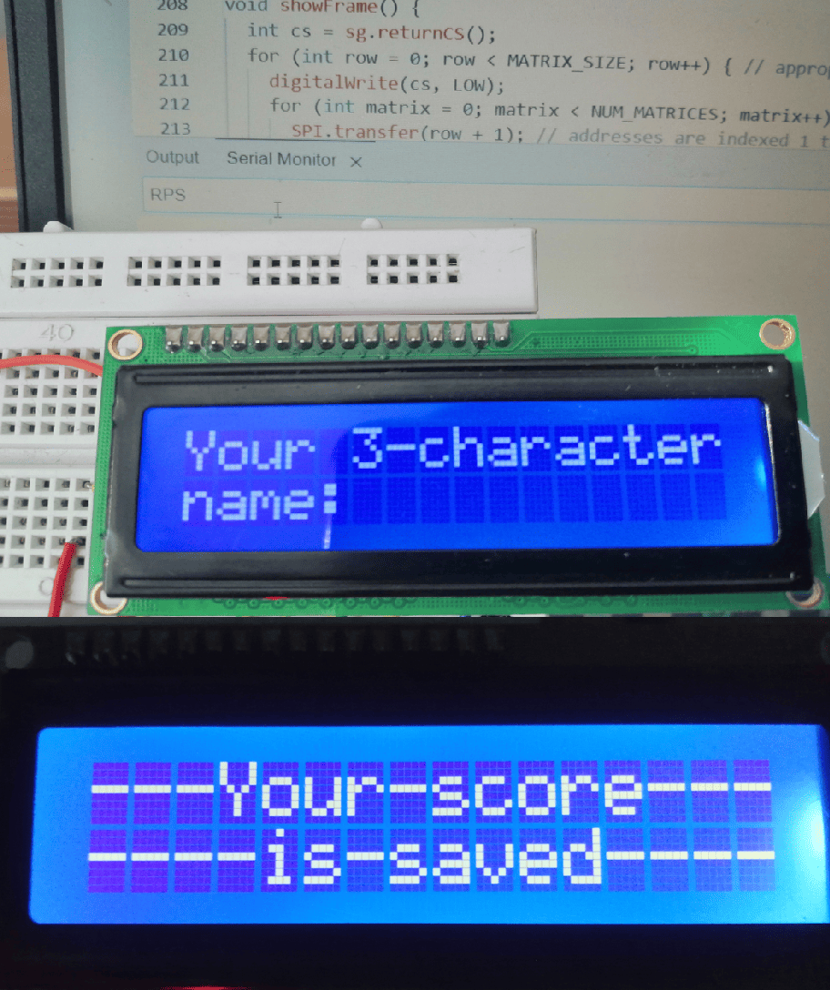
- Score memorising via serial communication.
If a user wants to see the best scores that are memorised, after pressing the yellow button, a sequence of screens will be shown on the LCD. This is shown in Fig. 13.
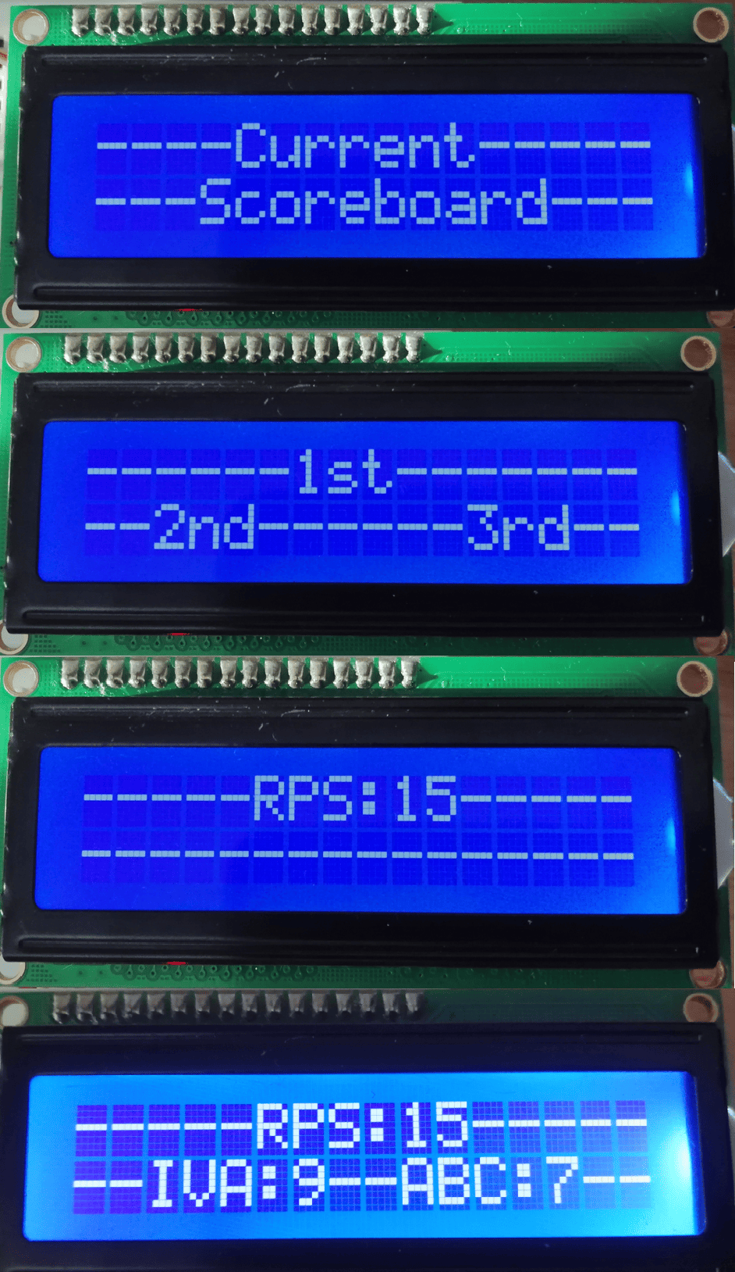
- Score showing sequence, for one and multiple memorised scores.

Conclussion
This solution for the Snake game was tested and its functionality was confirmed, although some improvements can be added.
Firstly, the whole schematic can be realised on a PCB (Printed Circuit Board), with it occupying less space and making the whole game circuit more compact.
Another improvement pertains to the joystick connection; when the joystick is connected via wires, some complications may occur, such as unplugging of the wires from the breadboard. Wireless connection may be a more suitable option.
In this version of the Snake, only one game mode is available. The game code and user interface can be expanded so that they contain different game modes.
Lastly, a piezo-buzzer can be added to the circuit, for the in-game sound effects.

Acknowledgment
The authors thank m. eng. Nikola Mitrović for supplying the needed components and devices, practical help in the laboratory, and suggestions in the making of this paper.

References
- Nokia website. Available at:
https://www.nokia.com/
- Taneli Armanto’s Linkedin profile. Available at:
https://fi.linkedin.com/in/taneli-armanto-4242145
- About the Snake game. Available at: https://www.itsnicethat.com/features/taneli-armanto-the-history-of-snake-design-legacies-230221/
- Arduino Nano datasheet. Available at: https://docs.arduino.cc/resources/datasheets/A000005-datasheet.pdf
- Arduino IDE. Available at: https://www.arduino.cc/en/software
- Proteus simulator. Available at: https://www.labcenter.com/downloads/
- MAX7219 datasheet. Available at: https://www.analog.com/media/en/technical-documentation/data-sheets/MAX7219-MAX7221.pdf
- LCM1602C datasheet. Available at: https://www.alldatasheet.com/datasheet-pdf/view/1221278/ETC2/LCM1602C.html
- ATmega328P datasheet. Available at: https://ww1.microchip.com/downloads/en/DeviceDoc/Atmel-7810-Automotive-Microcontrollers-ATmega328P_Datasheet.pdf
- About LED matrix. Available at: https://softwareparticles.com/learn-how-an-8x8-led-display-works-and-how-to-control-it-using-an-arduino/
- About SPI. Available at: https://www.analog.com/en/resources/analog-dialogue/articles/introduction-to-spi-interface.html
- More about SPI. Available at: https://www.circuitbasics.com/basics-of-the-spi-communication-protocol/

